**IAM Users Assignment**

1. Create 4 IAM users named “Dev1”, “Dev2”, “Test1”, and “Test2”.

2. Create 2 groups named “Dev Team” and “Ops Team”.

3. Add Dev1 and Dev2 to the Dev Team.

4. Add Dev1, Test1 and Test2 to the Ops Team.

Go to Iam Dashboard 🡪users 🡪create user. Fill the details

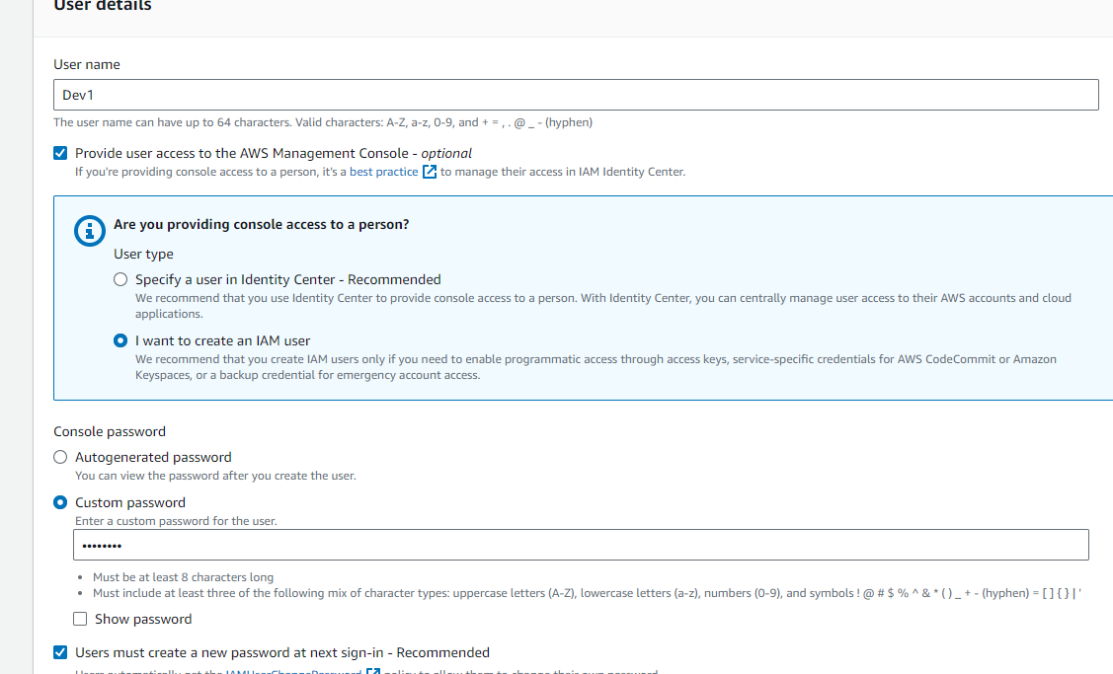

In the Next page don’t attach anything now as the assignment.

Just Review and create the user.

Like this create user Dev2 , Test1 and Test2 also.

Now go to Iam Dashboard 🡪usergroups 🡪create new usergroup.

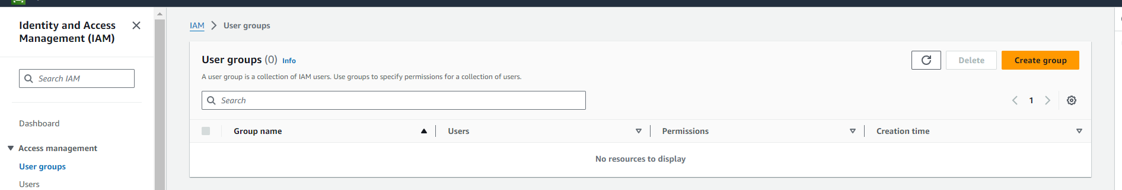

When click on create group new pop up will show.

Create Dev team group and add dev1 and dev2 to it. Create user group.

Create ops team group and add dev1 , test1 and test2 to it.

